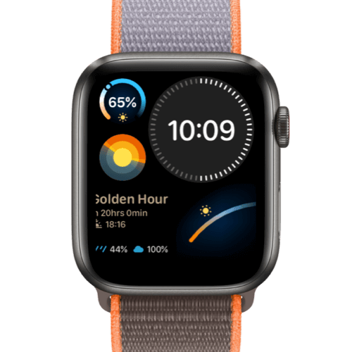**Description**: Suunto is a Finnish company known for its high-quality sports watches, dive computers, and precision instruments designed for outdoor enthusiasts and athletes. Established in 1936, Suunto has built a strong reputation for durability and innovation, offering advanced GPS navigation, heart rate monitoring, and altitude tracking in its devices. Popular among hikers, divers, and endurance athletes, Suunto products are designed to withstand extreme conditions while providing accurate data for performance improvement. With a focus on adventure and exploration, Suunto continues to develop cutting-edge technology to support users in their outdoor and fitness pursuits.